Some Information about Historical Model Yacht Racing on Orakei Basin
By Graham Barker 19 September 2016

It appears that model yachts were initially raced on the Orakei Basin prior to 1928 under the auspices of the Orakei Basin Model Yacht Club. In 1928 a new club was founded as Auckland East Model Yacht Club, which took over the model yacht racing on the Basin. (Refer Attachment A for more detail).

Photos from New Zealand Herald of 1935 in Attachment B show club members gathering with their yachts for sailing at the Basin. One photo also shows a boat shed, which presumably housed members’ dinghies that skippers used for chasing their yachts.

Below is a photo of model yachts racing on the Basin in 1937. The skipper of each yacht rowing with their yacht to cause it to tack and gybe as required to complete the course.

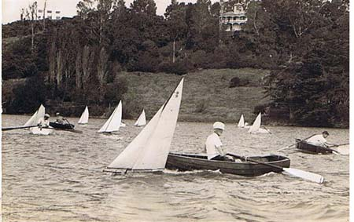

From discussion with Mr Bruce Anderson, who raced a similar yacht on the Basin in 1943 as a 13 year old, we have more information on the yachting of this era. He believes that the yachts in photo are of the 3-foot class, which is the same class of yacht that he sailed. Races were held on Saturdays because larger yachts such as P-Class, Frostbites and Z-Class were raced on the Basin on Sundays by another yacht club called the Orakei Yacht Club. Mr Alistair Bevan was very active in leading the Auckland East Model Yacht Club.

At this time the rock groin (or jetty) on the South side of the Basin had been constructed for launching the yachts. Also a substantial boat shed was adjacent to the rock groin for housing the dinghies used by the skippers of model yachts. A breezy day would cause the skippers to have a lot of exercise. Up to 10 yachts would participate in these races. The course would consistent only of upwind and downwind legs.

The 3-foot yachts had a beam of about 12 inches and deep lead bulb mounted on a metal skeg.

In 1951 the club introduced the 12-inch class of yacht, which had a strong following in Sydney. These yachts had 12 inch overall hull length but with bowsprits 16 inches long, mast height 36 inches and keels 15 inches deep. The club introduced a plastic version of these yachts at this time. (Refer Attachment A).

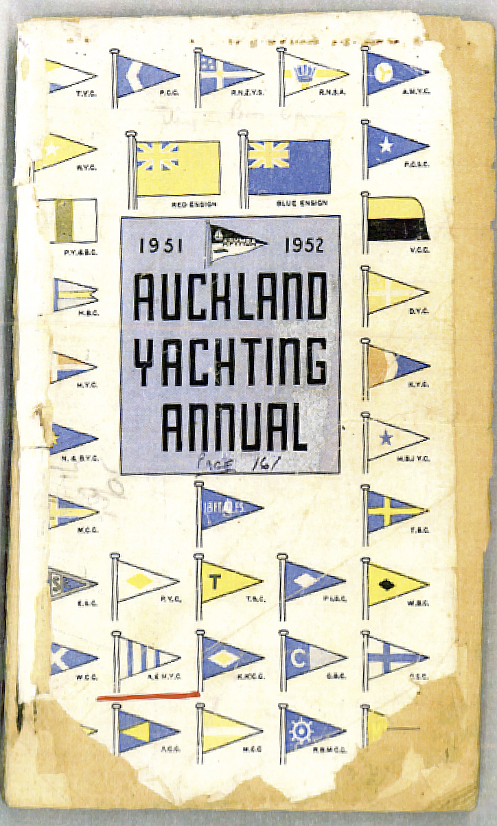

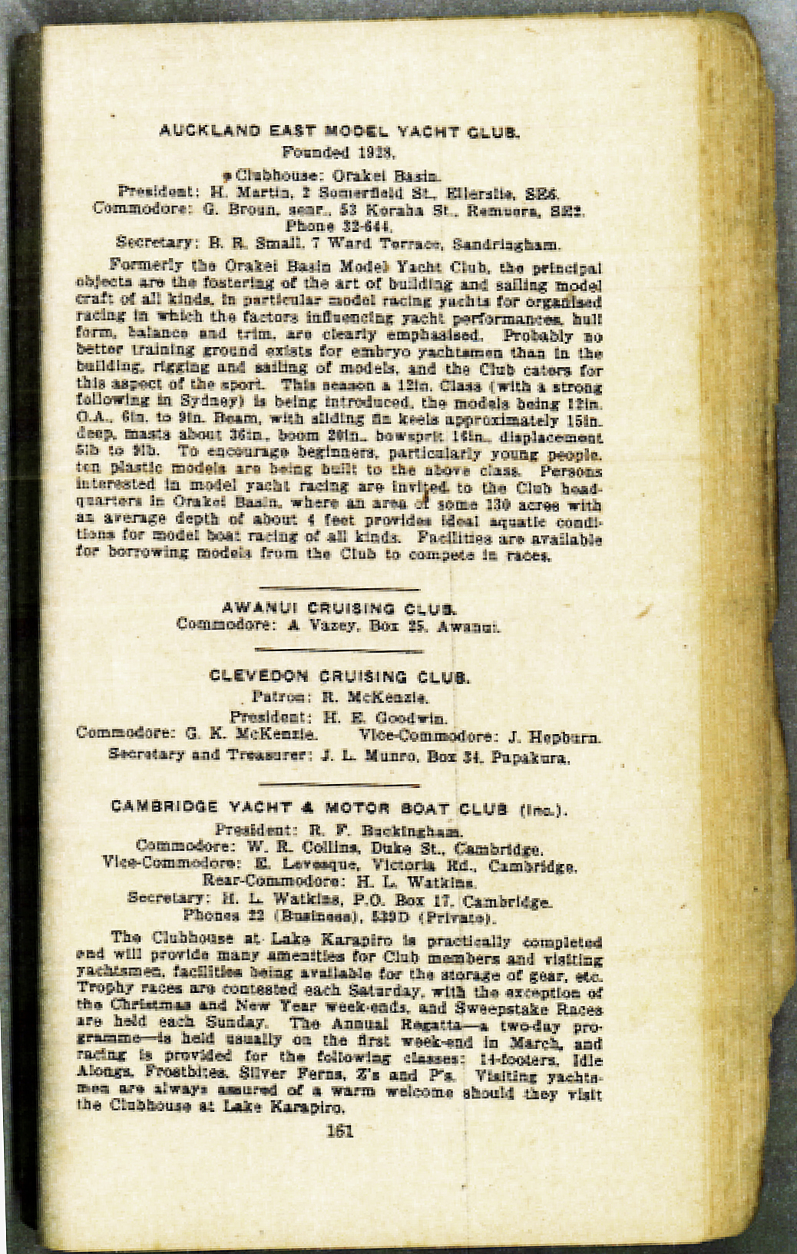

Attachment A – Information from Auckland Yachting Annual 1951/52
Provided by Ross Morton September 2014

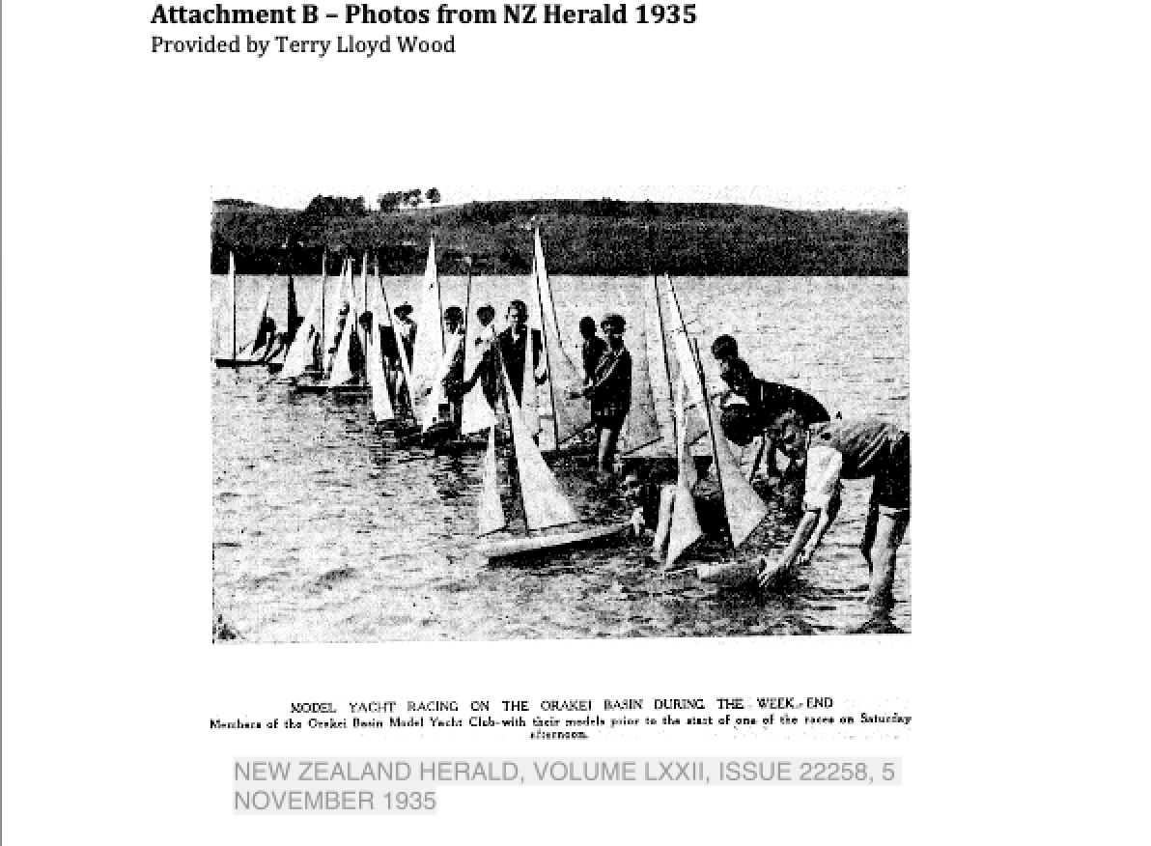

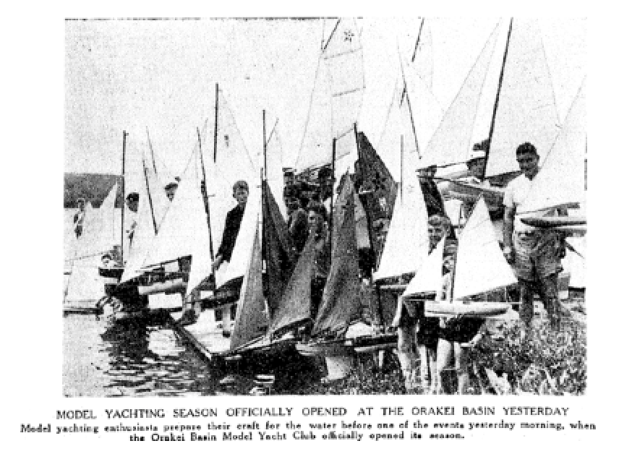
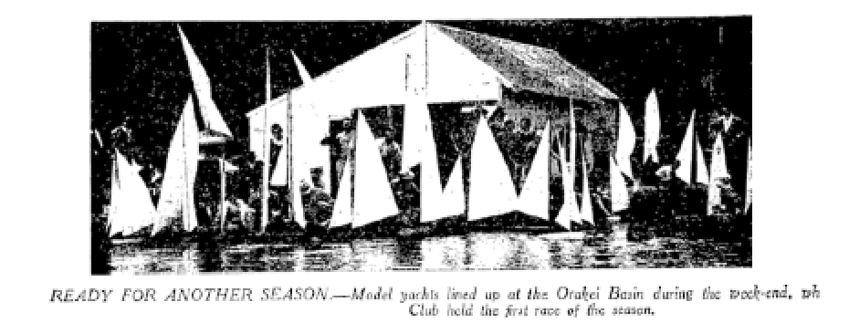

Attachment C is an advertisement for the Auckland Anniversary Regatta 1948 which shows that model yachts were raced on the Orakei Basin as part of the Regatta in that year.

